Revision history

**Version:** 1.0

**Date of creation:** 21/11/2021

**Team code: PRJ-CB05 3**

**Team name:** RASH

**Team members:**

* Stefan Popescu
* Anna Kowalewska
* Hristo Tanchev
* Rawan Alhabsi

Project plan

semester 2 project mediabazaar

Ania Kowalewska, Stefan Popescu, Hristo tanchev, rawan alhabsi

2021

|  |  |  |  |
| --- | --- | --- | --- |
| Version / Status | Description | Author | Date |
| 0.1 | First draft of the Project Plan, containing mostly everything for the completion of the project | Ania Kowalewska, Stefan Popescu, Rawan Alhabsi, Hristo Tanchev | 02/09/2021 |
| 0.2 | Project goal, Constraints | Ania Kowalewska, Stefan Popescu, Rawan Alhabsi, Hristo Tanchev | 07/09/2021 |
| 1.0 | Deliverables, Constraints,Phasing | Ania Kowalewska, Stefan Popescu, Rawan Alhabsi, Hristo Tanchev | 21/11/2021 |

Contents

1.About us 3

2.Roles 3

3.Client 4

4.Current situation 5

5.Problem description 6

6.Project goal 7

7.Deliverables 8

8.Non-deliverables 9

9.Constraints 10

10.Risks 10

11.Phasing 11

# 1.About us

**Team code:** PRJ-CB05 3

**Team members:**

* Stefan Popescu (s.popescu@student.fontys.nl)
* Anna Kowalewska (a. kowalewska@student.fontys.nl)
* Hristo Tanchev (h.tanchev@student.fontys.nl)
* Rawan Alalhabsi (r.alalhabsi@student.fontys.nl)

RASH is a group of IT students from Fontys University of Applied Sciences in Eindhoven. We develop software applications on demand to simplify the work activities of companies and to solve issues where needed within the work environment.

## 2.Roles

This team is made by a group of four Fontys University students who are aiming to help Media Bazaar company to manage their administration issues by using software solution, willing to ease their work in administration system.

2.1. Our Rule

Every week the role of the leader of the team will be switched to another member of the group, where the leader of the group is the one who is responsible of the progress that will be made in his week and for making meetings with the tutor or the client.

The order of the team leader:

1. Stefan Popescu

2. Rawan Alhabsi

3. Hristo Tanchev

4. Anna Kowalewska

# 3.Client

A new company named “MediaBazaar” wants to open its very first shop in Eindhoven. MediaBazaar is a warehouse which sells all kinds of products. However, they are still unsure how the store should be managed. Therefore, they are in need for a group of software developers to develop an application wherein the store will be managed. To do this correctly, clear requirements are needed. In every meeting with the client, there will be different requirements of the application/website.

**Contact details of new client:**

* Lara Rojas, John J.G.
* **j.lararojas@fontys.nl**
* 0622428741

# 4.Current situation

At this moment, MediaBazaar does not own a management system which is needed to run a local office here in Eindhoven. The system should be able to manage its employee’s data, work shifts departments, and products. Moreover, it needs to be able to automatically assign employee(s) to a specific shift. Also, statistics should be available for the management. MediaBazaar contacted multiple companies including us to create that management system. These companies are all working on this project. Eventually, the best one will be chosen and implemented by MediaBazaar.

**Current management methods:**

1. Work shifts are manually assigned to employees in excel sheets
2. Manual attendance checking by calling employee names during a live meeting
3. Manual stocks management in which you must count the number of products yourself
4. Data of employees is being stored on paper
5. Data of departments is being stored on paper

# 5.Problem description

MediaBazaar is at this moment unable to manage its employees, work shifts, departments, and products. Our client explained what kind of issues they deal with regarding the employees’ administrative system, workload, and shift management. On top of that, there are no statistics available to determine which product has been sold the most or employee was less available. Based on those statistics, the company can make important decisions.

# 6.Project goal

Looking at this project, the main goal is to digitalize the work environment of MediaBazaar. This will allow the employees of the company to focus and put more effort into more meaningful tasks. Also, with the new system, employees gain more trust in the company since their work activities will be simplified and that all while having a fair distribution of work shifts. Moreover, statistics are given of which employee works well or which product sells the most. Based on those statistics the management can make some important decisions. In addition to that, being able to assign shifts automatically and manage the store departments. In general, to automate the whole system.

# 7.Deliverables

It is good to know up front which products will be delivered during the project. The project is divided into 3 phases which last 6 weeks each. The first phase is via the waterfall method and the second and third phase via the agile method. The second and third phase also called the iterative phase will have four iterations in total. These are the deliverables regarding the first phase of management system project:

1. A project plan
2. An URS document
3. A first version of the C# Windows Form Application of a Management system (includes employee tab, department tab, shift tab)

These are the deliverables regarding the first iteration of the second phase:

1. A second version of the C# Windows Form Application of a Management system (includes scheduling tab which works manually, department tab, employee tab, shift tab, Product management form)
2. Updated project plan
3. Updated URS document

These are the deliverables regarding the second iteration of the second phase:

1. Updated project plan
2. Updated URS document
3. A third version of the C# Windows Form Application of a Management system (includes scheduling tab with auto scheduling function, department tab, employee tab, shift tab)
4. Process Report document
5. A first version of Employee’s Media Bazaar website with login functionality and Table with scheduled work shifts of logged in user.

# 8.Non-deliverables

However, it is also good to know up front which products will **NOT** be delivered during a project. These are the non-deliverables regarding the management system project:

1. Continuous technical support for the application will not be offered
2. The hardware features are out of scope for this project, only the software

# 9.Constraints

When working on a project there are always some constraints you must take into account to keep the client satisfied. These are the constraints regarding the management system project:

1. The application should be coded with C#, ASP.NET & JavaScript only, other code languages are out of scope for this project.
2. The application will be built in 3 phases and should be finished on the 2nd of February for Media Bazaar to open its shop on time. The end date of the first phase is the 27th of September, and the end date of the second phase is the 22nd of November.

# 10.Risks

* In case someone is sick and couldn’t contribute.
* In case someone in quarantine.
* In case someone quit (from the software developers’ team).

# 11.Phasing

This project is divided into 3 large phases. The first phase of the project which will be described here. Firstly, besides the documentation part that took place in the first two weeks. During the phase we were creating a plan about what, when and for whom we are going to develop the product.

By doing that we created a URS, in this documentation we instructed in steps the ways user is going to interact with the GUI.

Secondly, we created a logo and came up with a name that suits our team.

Lastly, an interview with the client that took place during the phase, which was the most important part.

During that interview we asked the client a couple of questions which gave us an idea how we are going to start our project and what must be developed.

On the last weeks of the first phase, we started with the implementation.

In the first iteration of the second phase, we extended the management system with more requirement such as a product management, an advanced searching functionality, a scheduler that works manually and some employees’ statistics. The URS and Project plan are updated as well.

In this iteration which considers as the second iteration of second phase, we continued extending the C# application and we created a website for employees to view their work shifts of the current month. Furthermore, employees can view their work shifts of previous and next month. Regarding the work shift scheduler, an automatic scheduling is done for the managers. A Process report is created which illustrates how did we divided the work, the reflections of each iteration and the personal reflection of each member of the group. The URS and Project plan are also updated in this iteration.

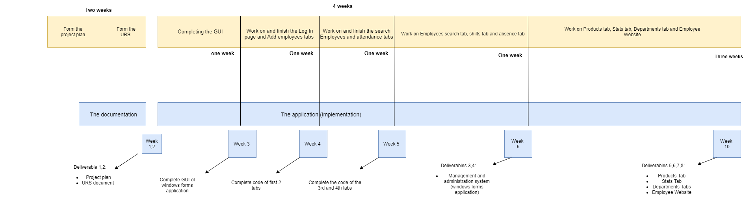Fig. 1. Phases Diagram